|  |
| --- |
| Geodesign Workshop University of Washington – Seattle 6-8 May 2015    **Evaluation Model Simplification Tutorial** |

**1. Introduction**

**Workflow rather than tool**

This tutorial covers a suite of geoprocessing tools designed to support a workflow for simplifying an evaluation model feature class within the geodesign framework. The initial motivation for this toolset was to reduce the file size of 10 evaluation model shapefiles so that they could be run efficiently on [Geodesignstudy.com](http://geodesignstudy.com/) during the Geodesign Workshop held 6-8 May 2015 at the University of Washington – Seattle. The tools and workflow described herein were designed to accomplish this in two ways: by reducing both the feature and vertex counts of a feature class. While the toolset is designed to support similar workshops in the future, it might also be used to simplify any geodesign evaluation model regardless of purpose. The workflow and tools were developed simultaneously and iteratively and so leave room for any alterations that you see fit while using them. While this tutorial assumes the general workflow they were intended to be used in, you are free to use the tools in whatever order you prefer and to edit them as you see fit. This tutorial also includes sample data to demonstrate the workflow. **Data provided by permission of King County**.

**Software Requirements**

The evaluation simplification tools were developed in ESRI’s ArcGIS version 10.2.2 and 10.3, so they are intended to be used in ArcMap version 10.1 or later – the most recently tested version was ArcGIS 10.3. A separate toolbox is provided for version 10.1/10.2 and for version 10.3. An Advanced (ArcInfo) license was the only one available during development, so it is unknown if other license levels are able to run the tools. The Spatial Analyst extension is also required to use one of the tools, Raster Focal Mean.

**Support**

While no formal support process is provided, please do not hesitate to contact John Ritzman at [jar29@uw.edu](mailto:jar29@uw.edu) with any questions or comments pertaining to these tools.

**2. Folder Contents**

After downloading and unzipping the folder, you will find the following:

1. A folder named **LayerFiles** that contains **Sys00_EvaluationTemplate.lyr**, the default 5-color (red-to-green) symbology for the evaluation models.
2. A folder named **Scripts** that contains two Python scripts that support the two script tools in the toolboxes.
3. A scratch geodatabase that will be utilized by the simplification tools for storing intermediate data, named **scratch.gdb**
   1. This geodatabase also contains three important template datasets, **EvaluationTemplate**, **StudyArea**, and the table **SystemDetails**.
4. A tutorial geodatabase with sample data from a groundwater evaluation and backups of the scratch geodatabase datasets, named **Tutorial.gdb**
5. An ArcGIS custom toolbox for version 10.1/10.2, named **GeodesignWorkshop_v10_2.tbx**
6. An ArcGIS custom toolbox for version 10.3, named **GeodesignWorkshop_v10_3.tbx**
7. A template MXD you may copy to create your own, named **EvaluationSimplification_Template.mxd**
8. This tutorial (not shown in ArcCatalog).

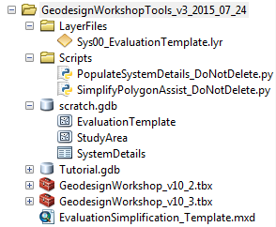

The tools in both toolboxes are set to use relative paths, so they should reference any support files needed for their operation already regardless of where you unzip the folder. That said, **do not move the folders, toolboxes, or geodatabases from their current *relative* locations** to each other, since many of the tools rely on relative paths to certain datasets. The functionality within each of the two toolboxes should be identical, so use the one appropriate for your version of ArcGIS – 10.1 users should use the 10.2 toolbox. This tutorial will use the 10.2 toolbox, but the workflow is identical for 10.3.

**3. Overview of Workflow**

**Introduction**

This tutorial assumes the end goal of a simplified 5-color (red-to-green) evaluation of a given system in the form of a GIS polygon feature class. For the geodesign workshop these tools were created for, these colors (Red2, Red1, Yellow, Green1, Green2) indicated the suitability of a given system (e.g. groundwater) to accommodate development across a study area, with Red2 (R2) being least favorable/highest risk, Yellow being unknown or neutral suitability and Green2 (G2) being most favorable/least risk. This tutorial assumes a similar activity, though it can be extended to any evaluation using a 5- or 3-color scale. The workflow to create this simplified evaluation feature class proceeds roughly in 3 steps:

1. Determine which evaluation color each of your source features falls into.
2. Combine all source feature classes into a single feature class and clean up topology (specifically gaps and overlaps within the study area).
3. Reduce the number and complexity of features while maintaining topology so that only the larger patterns within the study area remain.

While the toolbox itself focuses mainly on steps 2 and 3, step 1 is also important and so is covered by this tutorial as well.

**Toolbox Contents and Workflow**

The contents of one of the GeodesignWorkshop toolboxes are shown below.

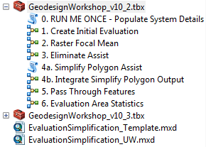

The toolbox comprises 8 tools. The workflow for a single evaluation begins at step **1. Create Initial Evaluation**, but the **0. RUN ME ONCE** tool must be run at least once before any evaluations can be run through these tools in order to define contextual information for the systems you intend to evaluate.

After running **0. RUN ME ONCE** at least once and running **1. Create Initial Evaluation** for your system, you may stop the workflow at any time if you are satisfied with your feature class. In addition, the tools after **1. Create Initial Evaluation** can be run in any order you prefer with the exception of the two **4. (Simplify Polygon)** tools, which must be run in succession. This, along with the parameters in each tool, enables you to customize the type of simplification that is done on your feature class and to what degree. The tools are ordered here in a recommended workflow that moves a feature class through 3 different types of simplification that we found useful for our feature classes. The last two tools (**5. Pass Through Features** and **6. Evaluation Area Statistics**) are also not specifically part of the workflow, but provide utility functions to either pass features from a previous step into your current step or to give a summary of the area and # of features for each color, usually used at end of the workflow. Tools **2-4** provide the heart of the simplification workflow, providing 3 different types of simplification.

**2. Raster Focal Mean** rasterizes your feature class and performs [Focal Statistics](http://resources.arcgis.com/en/help/main/10.2/009z/009z000000qs000000.htm) (MEAN) from ArcToolbox a number of times before converting back to a polygon feature class. This quickly smooths over small variations (features) in your evaluation and round out sharp transitions between features that do remain.

**3. Eliminate Assist** performs the [Eliminate](http://resources.arcgis.com/en/help/main/10.2/0017/00170000005p000000.htm) tool from ArcToolbox on your evaluation, which will merge any selected features with their larger neighbors. This pairs well with a Select By Attribute on the Shape_Area field (e.g. Shape_Area > 2500000) to provide a way of quickly eliminating smaller features so that only large features remain. A manual selection can also be used to pinpoint exact features to remove.

**4. Simplify Polygon** tools. Where the previous two tools focus on reducing the number of features, these two tools focus specifically on simplifying the polygon geometry (boundaries), as vertex count can also increase the size of shapefile. The first tool runs the [Simplify Polygon](http://resources.arcgis.com/en/help/main/10.2/0070/007000000011000000.htm) tool from ArcToolbox and the second cleans topology.

The recommended order of these tools comes from the fact the **Raster Focal Mean** quickly reduces the feature count and smooths geometry, making it a good first tool. The **Simplify Polygon** tools work best when there are no small features remaining, making **Eliminate Assist** good to run before that. The **Simplify Polygon** tools also clean up the grid cell-like boundaries of polygons left over from the rasterization from **Raster Focal Mean**, making them recommended to run after that anyways. You can also run additional **Eliminate Assist**s after the **Simplify Polygon** tools, but you should *not* end your workflow on **Raster Focal Mean** – or, rather, not end your workflow without running the **Simplify Polygon** after your most recent **Raster Focal Mean** – for the reason just mentioned.

It is also worth mentioning that each of the tools have topology cleanup functions in them as well, making them generally preferred over running the referenced tools directly from ArcToolbox. For example, **5. Pass Through Features** is sometimes useful if you want to a preserve a small or highly detailed feature from a previous step by bringing it into your current (or final) step. It ensures that the area where this new feature is being added is erased to prevent overlap and also checks if it can be merged with a now-neighboring feature of the same color, helping to reduce feature count.

Finally, **6. Evaluation Area Statistics** returns a separate table and is useful to run on your final simplified feature class and also on your first feature class (output from **1. Create Initial Evaluation**). This can help you determine, for example, if your simplification process has selectively changed the percentage area of a certain color within your study area (if it has “lost ground” in the process), to assess how well your simplified version accurately preserves the important trends from your original evaluation.

The tools all make use of the scratch geodatabase (scratch.gdb) to ensure that intermediate datasets do not clash with your working geodatabase and do not have to connect to an ArcSDE geodatabase if you are using one. Your evaluation will also be converted to the Evaluation Template schema during the **1. Create Initial Evaluation** tool, which is minimalist for performance’s sake and can be previewed in the scratch geodatabase. Using this feature class as a template is essential as many of the tools work off of certain fields that they expect, so do not skip the **1. Create Initial Evaluation** tool or add or remove any additional fields afterwards, at least until you are done with the simplification toolbox.

Finally, the tools all have extensive metadata and tooltips that can help with usage. Right-click any tool in the toolbox and go to Item Description for details about it.

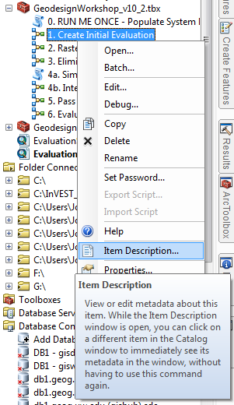 🡪 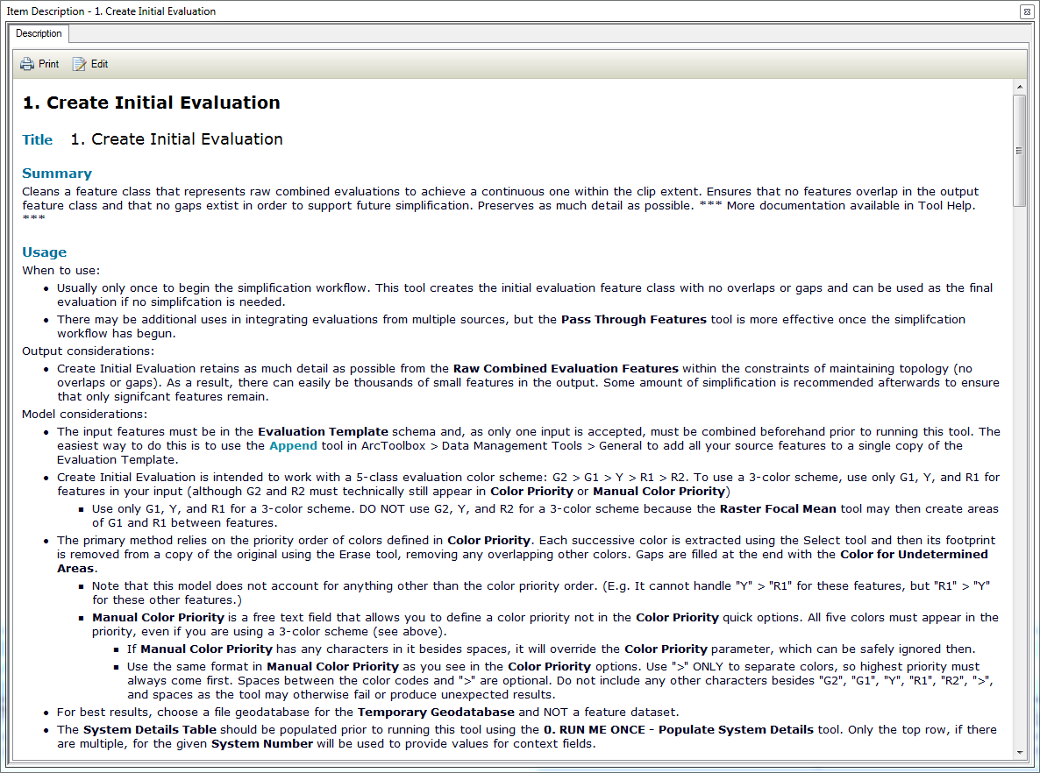

**4. Data Preparation**

**Preliminary**

The tools are most easily run from within ArcMap so that you can see the results of each step and compare output from different steps of the workflow using the red-to-green symbology. There is a map document **EvaluationSimplification_Template.mxd** in the folder after unzipping that you can copy/paste and rename in the same folder so that it is easy to find the toolbox and scratch geodatabase from that map document. You may also use any map document you wish and just navigate to the toolbox to use tools. Output from tools may be to any geodatabase (file, ArcSDE, etc.) that you are using.

**Contextual Information**

In order to start the workflow, the first tool that must be run is **0. RUN ME FIRST – Populate System Details**. This tool allows you to fill out contextual information for the systems that will be evaluated during your project. The main functional reason this tool exists though is to populate a couple fields in the Evaluation Template schema that will allow you to deduce what the feature class is even if its name is changed. The tool simply replaces the records in the SystemDetails table in the scratch geodatabase with the rows you define in the tool dialog box. These records will then be read during the **1. Create Initial Evaluation** tool.

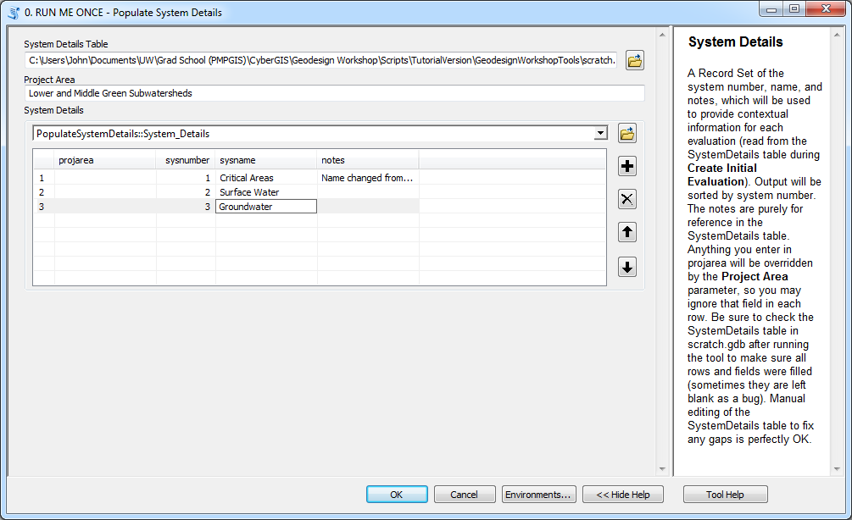

This tool basically just gives a similar interface to editing the table itself in ArcMap, with a little added functionality. If you prefer, you may actually skip this tool and add rows to the SystemDetails table itself in ArcMap, ensuring that you fill in the ***projarea***, ***sysnumber***, and ***sysname*** fields for each row. If you decide to use the tool, filling out the second parameter, **Project Area**, means that you can skip writing the same project area in the ***projarea*** column in the third parameter (see screenshot). To use the third parameter, **System Details**, do not change the dropdown value at the top, but instead just click the plus icon to add rows to the temporary table, which you can then fill values for. You can see how many rows you have added with the numbers at the far left of the big box (the ObjectID). The notes column is optional, but the ***sysnumber***, and ***sysname*** fields are required. Use arbitrary numbers and names if needed.

Note that running this tool will replace any rows currently in the SystemDetails table. If you wish to edit any rows and add new ones without deleting the old, please edit the table directly in ArcGIS. Avoid running this tool very often as it is not really necessary; the context fields can be edited directly in the evaluation feature classes if needed.

This tutorial document does present a sample workflow with sample data (currently in **Tutorial.gdb**). If you wish to follow this sample workflow, fill out the second and third parameters as shown above, with three rows in the third parameter. We will be evaluating a groundwater system. Otherwise, enter your own system details here.

**Preparing the evaluation template and study area**

The next step actually does not reference the toolbox at all, but involves ensuring that two support datasets are set up correctly in the scratch geodatabase. Like the SystemDetails table, these two datasets should only need to be prepared once and can then be used to support the simplification of all your evaluations.

First, the **EvaluationTemplate** feature class needs to be changed to the coordinate system that you are using. The EvaluationTemplate feature class itself should be empty as you will only be working with copies of this feature class, you should be able to just change its coordinate system by **right-clicking > Properties > XY Coordinate System**. If one of your source feature classes is in your ArcMap document, its coordinate system will appear in the “Layers” folder at the bottom of the selection window (see following page). Select the appropriate coordinate system for your data. If you are doing the tutorial workflow, the EvaluationTemplate should already be in the correct coordinate system, ***NAD_1983_HARN_StatePlane_Washington_North_FIPS_4601_Feet***, unless you have done other work on the same geodatabase. If needed, add a feature class from Tutorial.gdb so this coordinate system appears under “Layers”.

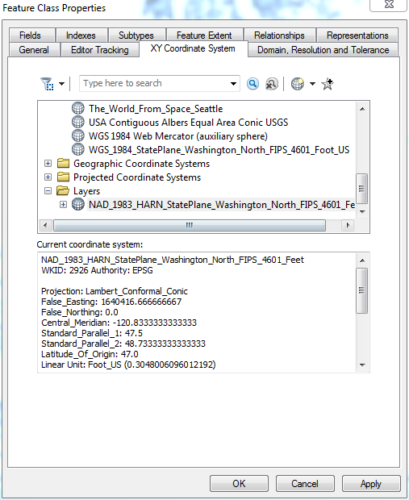

The second support dataset required is your study area. This has to be a polygon feature class, but can contain multiple polygons – this has been tested with contiguous polygons, but not ones with gaps, although there should be no problem then either. Attribute fields are not important here, so it is easiest just to delete **StudyArea** from the scratch geodatabase and copy/paste (or import) a feature class of your own to replace it. Make sure to rename your study area feature class **StudyArea**; this will cause the tools to automatically use it by default for the **Clip Extent** parameter, saving you a step with each tool. You may also specify a different feature class for the Clip Extent in each tool if you prefer. The **StudyArea** feature class should also be in the same coordinate system that you just set the **EvaluationTemplate** too, which should be the same that your source data is in. The **StudyArea** feature class that is in the scratch geodatabase when you first unzip the folder is the one for the tutorial data. If you have replaced this one with your own and want to run the tutorial again, delete the current one and copy/paste the **StudyArea** feature class within the Base feature dataset in Tutorial.gdb to the scratch geodatabase (be sure to rename it just **StudyArea**).

**Preparing your own data**

The next step also does not reference the toolbox at all, but involves classifying the source features that you will import to the Evaluation Template at the start of the workflow. These features may be in the same feature class or in multiple feature classes, but all must be polygon. In addition, you will need to add a ***color*** field to each to feature class and populate it with values corresponding to the 5 colors used for evaluation (R2, R1, Y, G1, G2). The color field should be added to each feature class as shown below, a Text field of length 10; ***color*** should be lowercase.

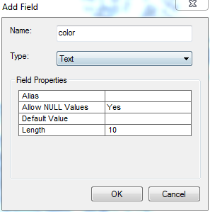

G2 will be treated as the most favorable/least risk and R2 will be treated as least favorable/most risk. Use ArcGIS’s [Field Calculator](http://resources.arcgis.com/en/help/main/10.2/005s/005s00000029000000.htm) or direct editing to populate the ***color*** field for your features with “R2”, “R1”, “Y”, “G1”, or “G2”. Any features with <Null> in this field will all be given the same color (of your choice) during the **1. Create Initial Evaluation** tool. Another thing to keep in mind is that *this field is all that the simplification tools will know about your features*. Nothing will distinguish between features of the same color once you import into the EvaluationTemplate.

If you are using just a 3-color (red-yellow-green) evaluation structure, use only “R1”, “Y”, and “G1” then. *DO NOT* use “R2”, “Y” and “G2” for a 3-color system due to how the **2. Raster Focal Mean** tool functions – it will create “buffers” of R1 and G1 in between Y and R2 or G2 features. Avoid this by only using R1, Y, and G1 for a 3-color evaluation.

If you are doing the tutorial workflow, this step has already been done for you. The 5 feature classes in ***Tutorial.gdb\Phase2_Proc_Sys03_Groundwater*** were developed to comprise the 5 colors related to the groundwater evaluation. They will be used in the upcoming step.

**Creating the raw combined evaluation**

The next step in preparing your data is to combine all the source feature classes into one feature class in the Evaluation Template schema. This can be done using two default ArcToolbox tools. The first is Copy Features.

1. Open the **Copy Features** tool in ArcToolbox > Data Management Tools > Features.
2. Select the ***EvaluationTemplate*** feature class in the scratch geodatabase as theInput Features.
3. Place the Output Feature Class wherever you would like to store the steps of your simplification process, as this is where it begins.
   1. This should be in your own geodatabase, *not* the scratch geodatabase, which is mainly designed for intermediate datasets of the tools themselves.
4. If doing the tutorial, place the output in the ***Tutorial.gdb\Phase3_Eval_Sys03_Groundwater*** feature dataset and call it ***Sys03_Groundwater_EvalRawColors***.

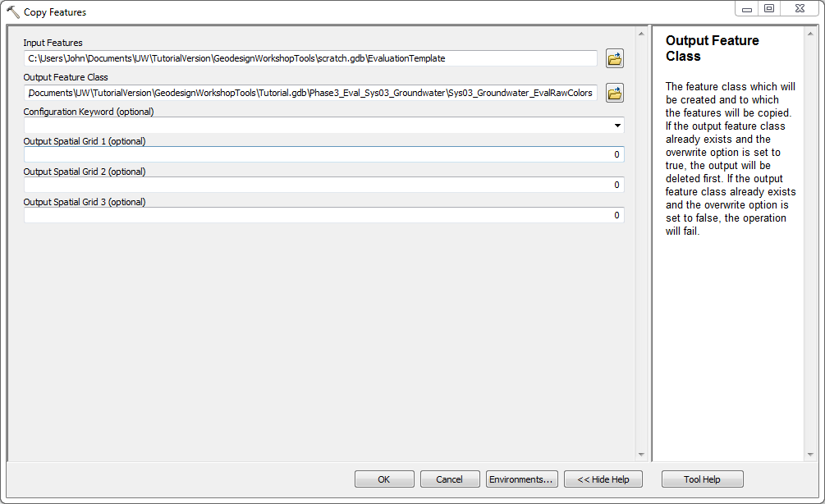

Click OK. The output feature class should be added to the ArcMap Table of Contents, although it should also be empty, so nothing should show on the map (delete features if any are present in it).

Next is the Append tool, which we will use to fill this empty copy of the template with your source features.

1. Open the **Append** tool in ArcToolbox > Data Management Tools > General.
2. For Input Datasets, add all of your source feature classes which you added and calculated the ***color*** field for. If any of these are ArcMap layers, be sure they have no selection on them, as only selected features will be added for layers.
   1. For the tutorial, this is the 5 feature classes in ***Tutorial.gdb\Phase2_Proc_Sys03_Groundwater*** (see screenshot below).
3. For Target Dataset select the newly created copy of the template, either the ArcMap layer or its feature class on disk.
   1. For the tutorial, this will be ***Sys03_Groundwater_EvalRawColors***.
4. Set Schema Type to “NO_TEST” and ensure that each of your input datasets has a corresponding field under the ***color*** field in the Field Map parameter.
5. Click OK.

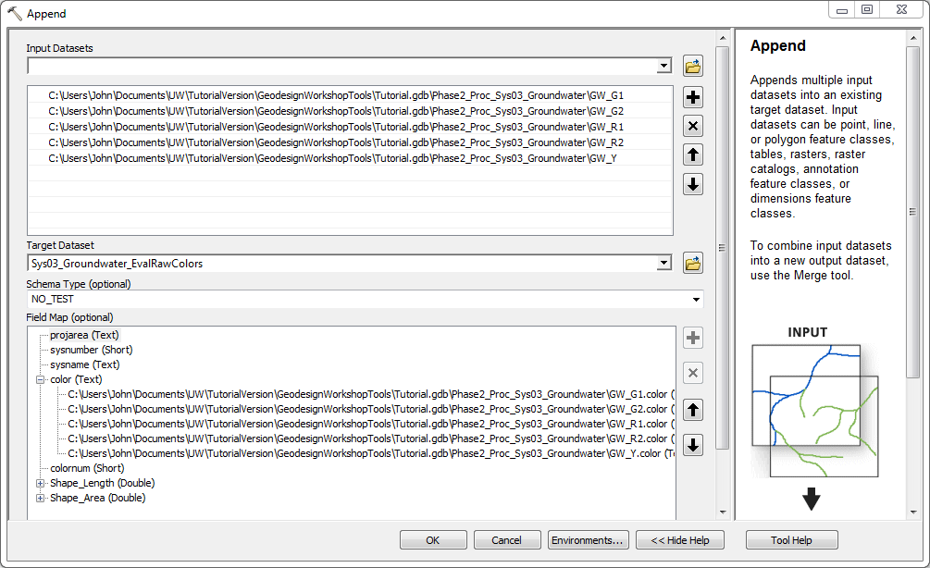

Your “_EvalRawColors” layer should now have features in it, although you may have to right-click it > Zoom to Layer to find them. There is now only one final step left before your evaluation feature class is ready for the simplification workflow.

**Creating the initial evaluation**

The final step in preparing your data is to run this “raw combined” feature class through the **1. Create Initial Evaluation** tool, which will clean its topology (gaps and overlaps) and clip it to your study area. You may then use this feature class as your final evaluation if you desire, or pass it through the simplification tools.

1. In the GeodesignWorkshop toolbox, open **1. Create Initial Evaluation**.
2. For Raw Combined Evaluation Features, select the “raw combined” layer you just created and filled.
3. For Output Evaluation Feature Class, place it also in your working geodatabase or feature dataset.
   1. Tutorial: Place in ***Tutorial.gdb\Phase3_Eval_Sys03_Groundwater*** and call ***Sys03_Groundwater_NoSimplification***.
4. Color Priority sets how overlaps are resolved. To select a color priority think of if an R2 (least favorable) and G2 (most favorable) feature overlapped; which would you call the area? This may be different for each system you evaluate.
   1. Manual Color Priority is available if you need to select a color priority different from the list given. Follow the same structure as Color Priority, using only “>” and including each color only once. Otherwise, leave this blank.
5. Color for Undetermined Areas sets how gaps are resolved. Any gaps or areas where only features with <Null> color are are set to this color. Popular values are “Y” (neutral unless otherwise), “R2” (least favorable unless otherwise), or “G2” (most favorable unless otherwise).
6. System Number is the number from the ***SystemDetails*** table for the system that you are evaluating. Open the table to look if necessary.
7. The rest of the parameters should be fine as default as long as Clip Extent is showing up as the **StudyArea** feature class and you have been following instructions until now.
8. **Tutorial values:**
   1. Raw Combined Evaluation Features:

***Sys03_Groundwater_EvalRawColors***

* 1. Output Evaluation Feature Class:

…***Tutorial.gdb\Phase3_Eval_Sys03_Groundwater\Sys03_Groundwater_NoSimplification***

* 1. Color Priority:

“R2>R1>Y>G1>G2”

* 1. Color for Undetermined Areas:

“Y”

* 1. System Number:

3

1. Click OK.

This tool may take a while to run. When it is finished, your output should show on the map using the red-to-green symbology.

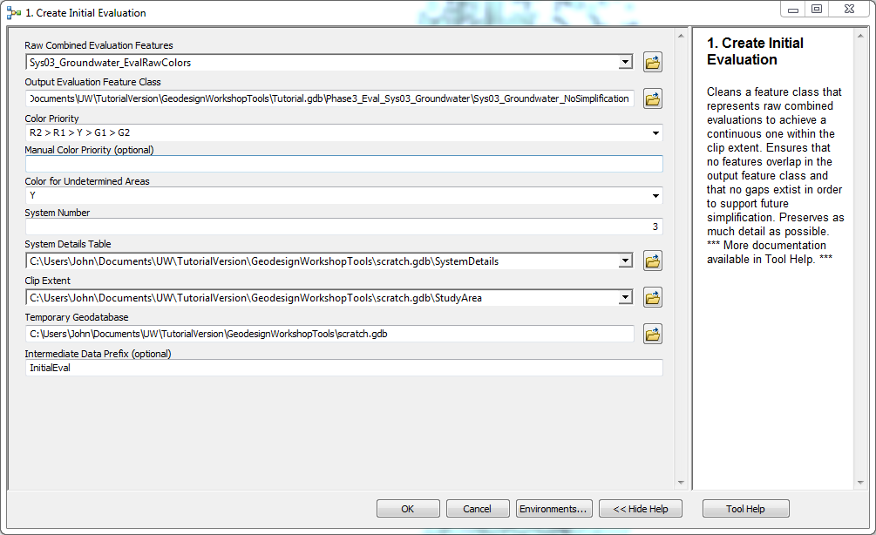

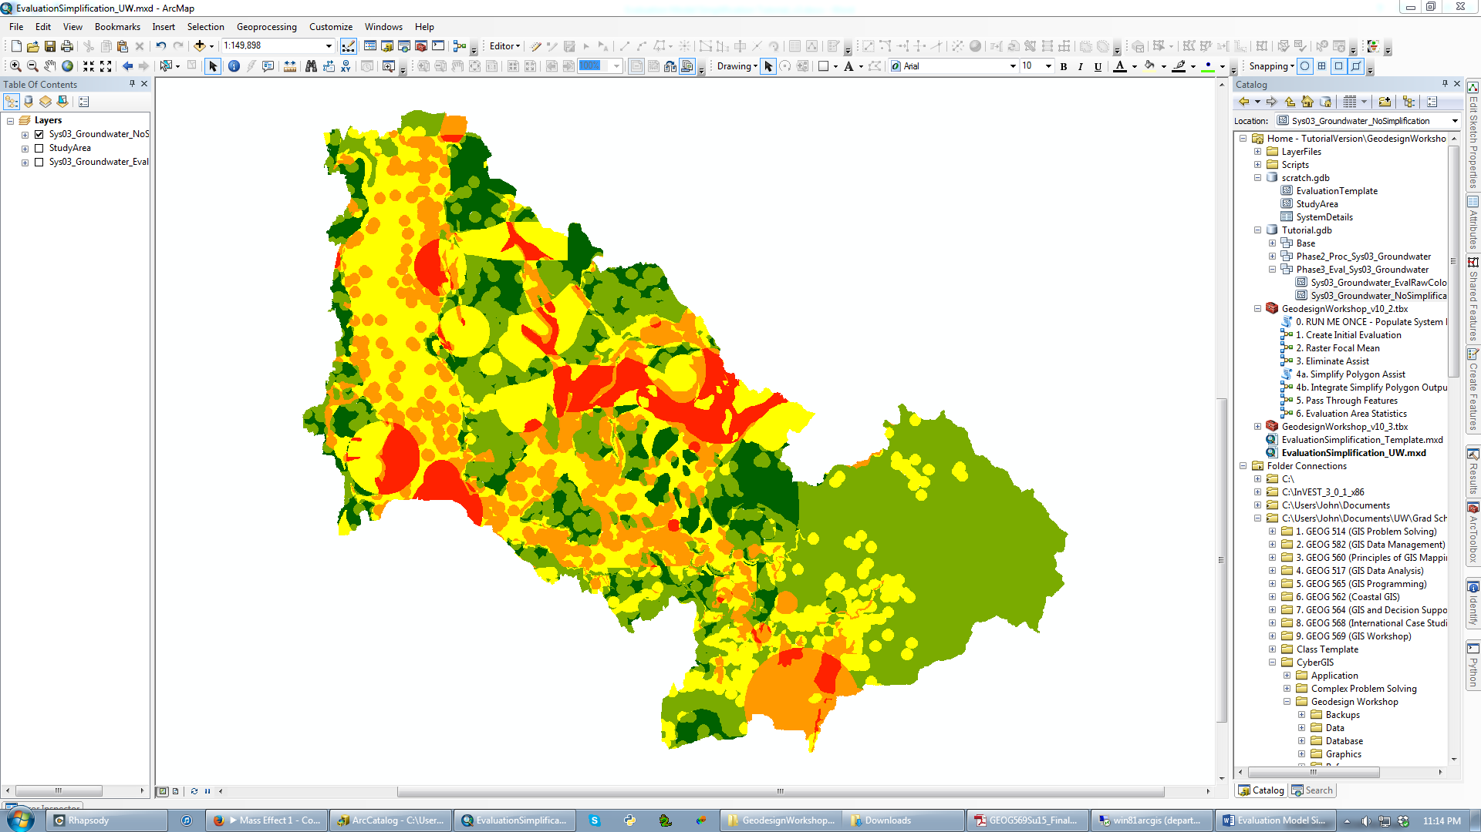

***Data provided by permission of King County***

Your evaluation features class is now ready for the simplification part of the workflow. It is a good idea to check this initial evaluation feature class to make sure it makes sense with the data you intended. Once you have verified that it has been created as you desired, you can always return to it if you ever need to restart your simplification.

**5. Simplification Workflow**

**Introduction**

While the evaluation feature class has been clipped to the study area and cleaned topologically, it has not been simplified other than that. This means that many small features may still remain that may not be consequential at the focal scale of your analysis – for example, the tutorial feature class has 1256 features at this point. To preserve the larger trends while reducing file size, the simplification workflow in the GeodesignWorkshop toolbox has 3 main tools that are recommended to be used in a particular order. **2. Raster Focal Mean** uses raster smoothing to quickly reduce feature count and round polygon boundaries, but leaves a grid cell-like appearance if zoomed in. **3. Eliminate Assist** merges selected features with their neighbors and can be used to eliminate any remaining small features quickly. **4. Simplify Polygon** are two tools that smooth and straighten polygon edges, removing the grid cell-like appearance from Raster Focal Mean. It is recommended that you run Simplify Polygon at some point after any Raster Focal Mean, but the tools can otherwise be chained in any order, even multiple times, in order to achieve the benefit of all 3 types of simplification.

**2. Raster Focal Mean**

This tool works by converting your evaluation features class to a raster, running [Focal Statistics](http://resources.arcgis.com/en/help/main/10.2/009z/009z000000qs000000.htm) (MEAN) on it multiple times, and converts it back to polygon with some geometry cleaning. This tool works well early in the workflow as it can quickly smooth over small features. ***You will need the Spatial Analyst extension enabled for this tool, which can be turned on in Customize > Extensions at the top menu in ArcMap.***

1. In the GeodesignWorkshop toolbox, open **2. Raster Focal Mean**.
2. Input Evaluation Features is the feature class you would like to simplify. If you are just starting the workflow, it is your unsimplified evaluation.
3. Output Simplified Evaluation Feature Class you should put in your project geodatabase or feature dataset.
4. Simplification Neighborhood is the area a cell that will be averaged to replace that cell’s value. A larger simplification neighborhood will lead to greater simplification.
   1. Rectangular neighborhoods with odd and equal values for height and width (e.g. 5 x 5, 11 x 11) tend to perform best because they create symmetric neighborhoods, leading to “fair” averaging.
   2. The default 9 x 9 cells we found is a good baseline for using a 30m rasterization of a feature class (see Import Cellsize parameter).
5. Passes is the number of times Focal Statistics (the average smoothing) is run. It can be between 1 and 5 and 5 is preferred in most instances to achieve the greatest simplification.
   1. 1 pass is useful in certain situations, such as cleaning the boundary of a feature just added using **5. Pass Through Features**.
6. Import Cellsize is the resolution of the raster that will be created from your input feature class, in the units of your input feature class (e.g. feet for the tutorial). A larger value here will lead to greater simplification, but a “blockier” output feature class.
   1. **The units for cellsize are the units of your input features’ coordinate system (usually feet or meters).**
   2. The default is the smaller of 1/250 of the length or width of the extent of your feature class. **We found a much smaller cellsize to be most effective here such as 30 meters (98.425 feet), so do not ignore this parameter.**
   3. If you are using the Snap Raster parameter, this should be the same as the cellsize of the snap raster (right-click > Properties the raster if unsure).
7. Snap Raster is useful if your source data originated from a raster (e.g. a land cover raster). Entering that raster here will ensure that the grid cells line up with the original raster’s cells, potentially leading to a higher quality rasterization of your feature class.
   1. If you set a snap raster, be sure that the Import Cellsize parameter is the same as that raster’s cellsize (right-click > Properties the raster if unsure).
8. **Tutorial values:**
   1. Input Evaluation Features:

***Sys03_Groundwater_NoSimplification***

* 1. Output Simplified Evaluation Feature Class:

***…Tutorial.gdb\Phase3_Eval_Sys03_Groundwater\Sys03_Groundwater_StepA01_RasterFocalMean_9x9_5Pass***

(This is a long suffix, but is useful in keeping track of work.)

* 1. Simplification Neighborhood:

Rectangle: 9 x 9 cells

* 1. Passes:

5

* 1. Import Cellsize:

98.425 (this is 30m in feet, the resolution of the raster below)

* 1. Snap Raster:

***…Tutorial.gdb\Base_NLCD2011_Project***

1. Click OK.

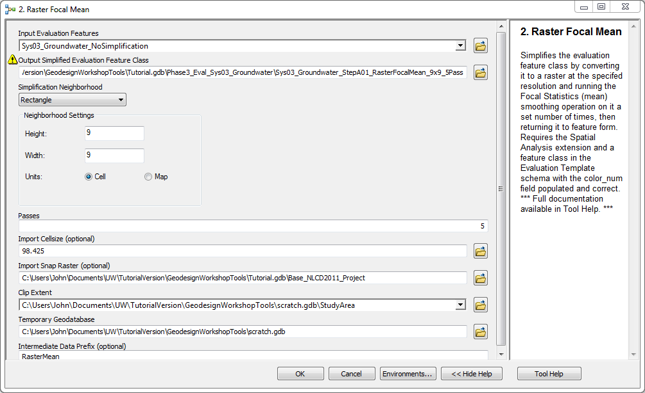

The output should be added to your map.

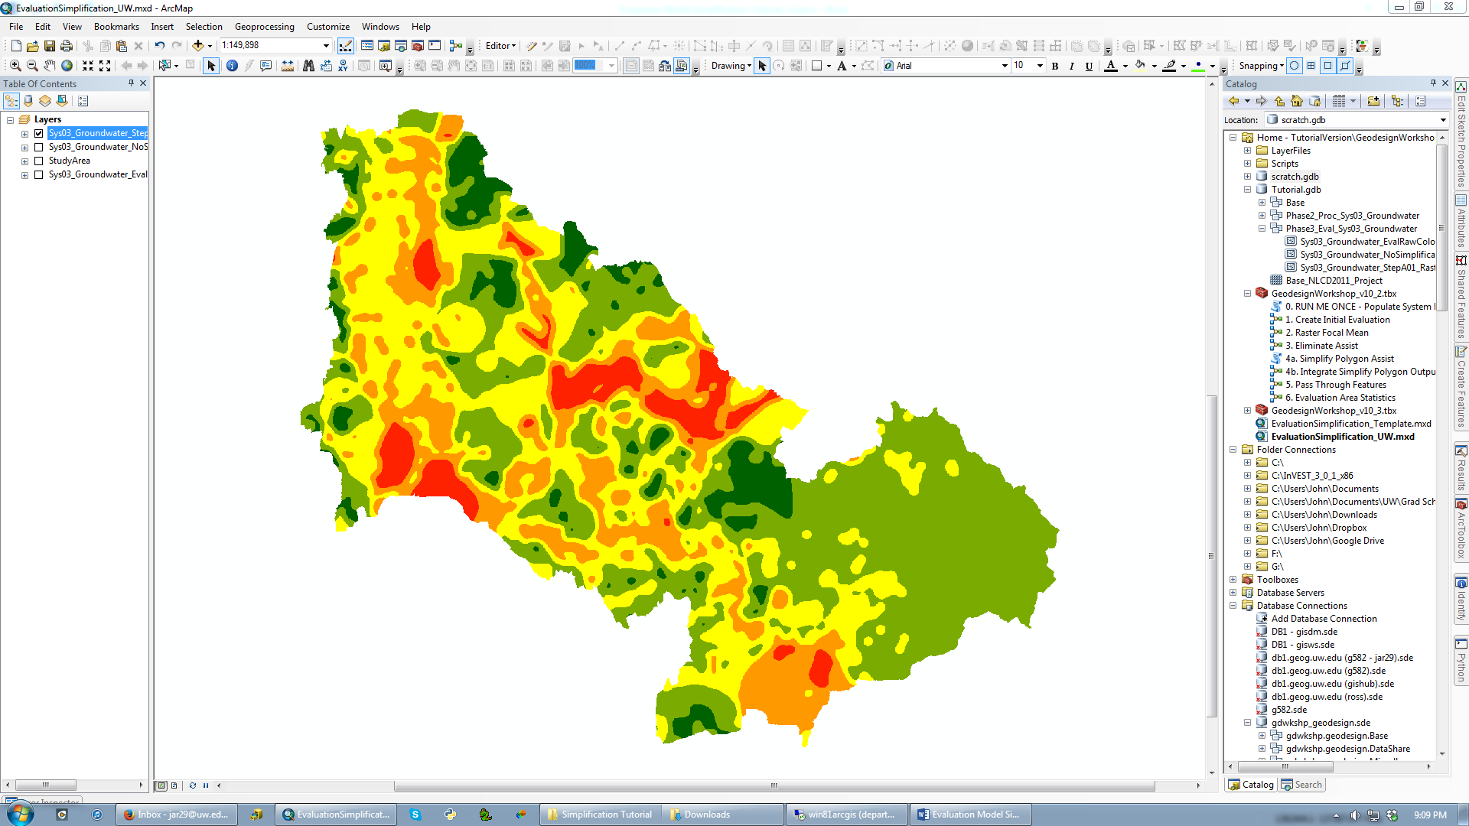

***Data provided by permission of King County***

**Advantages:** Effectiveness. In the tutorial, this reduced the initial evaluation from 1256 features to 219. It also maintains the original locations of colors very well as it just applies an averaging “smooth filter” to the data before rounding back to the 5 colors.

**Disadvantages:** The rasterization leaves polygon boundaries looking blocky, requiring the **4. Smooth Polygon** tools to be run afterwards to clean up. This tool also tends to create “buffer” features in places where neighboring features originally differed by more than one color step (e.g. R2 and Y). This is because the averaging function calculates a value between these two colors (R1) along the boundary between them. This can lead to colors’ appearing where they never were before, which can be very strange. The **3. Eliminate** tool can help to remove these buffers, but it is often much easier just to leave them in and deal with them like any other feature at that point. Regardless, these two issues mean that **Raster Focal Mean** should never be the last tool you use in your workflow.

**3. Eliminate Assist**

While the Raster Focal Mean tool can quickly reduce the number of small features, the **3. Eliminate Assist** tool does this directly without affecting other features. This tool is actually just the [Eliminate](http://resources.arcgis.com/en/help/main/10.2/0017/00170000005p000000.htm) tool from ArcToolbox with some topology cleanup afterwards, so all of the considerations for that tool also apply to this one. Eliminate works by merging selected features in the Input Layer with their unselected neighbors, enabling you to remove any features you desire. This tool was found most useful when combined with a [Select By Attributes](http://resources.arcgis.com/en/help/main/10.2/00s5/00s500000021000000.htm) to select features smaller than a certain area (see below). Additional qualifications can be added this way as well, such as omitting certain colors so that they are saved even if the features are small. If all else fails, you can [interactively select](http://resources.arcgis.com/en/help/main/10.2/00s5/00s50000000w000000.htm) features to be removed/merged. This is most easily done in ArcMap with all other layers turned off so that you do not select from other layers as well. ***Finally, if there are selected features that complete surround other selected features, the tool will need to be run multiple times in succession as these features will “buffer” each other from the merging.***

1. Before this tool can be run, you *must* select features in the layer you intend to simplify. The tool will not run without a selection. You may use interactive selection, Select By Attributes, Select By Location, etc.
   1. If you can, using a Select By Attributes query instead of a manual selection helps make your simplification workflow clearer and easier to repeat and document.
   2. A common selection to use is a Select By Attributes on the Shape_Area field to select all features smaller than a certain threshold. Run multiple selections to get a feel for how many features will be removed. This can also be combined with a selection on the color field to save important features that might otherwise be below the area threshold. Examples:

Shape_Area < 2500000

Shape_Area < 5000000 AND color NOT IN (‘R2’, ‘R1’)

* 1. It is also often a good idea to check the number of features you have selected before running this tool, either in the attribute table or at the bottom-left of ArcMap (see second screenshot).

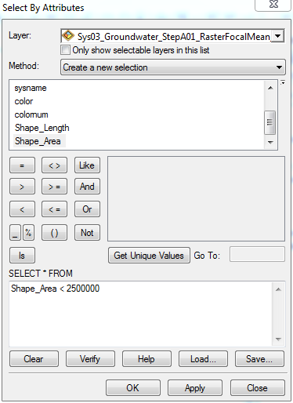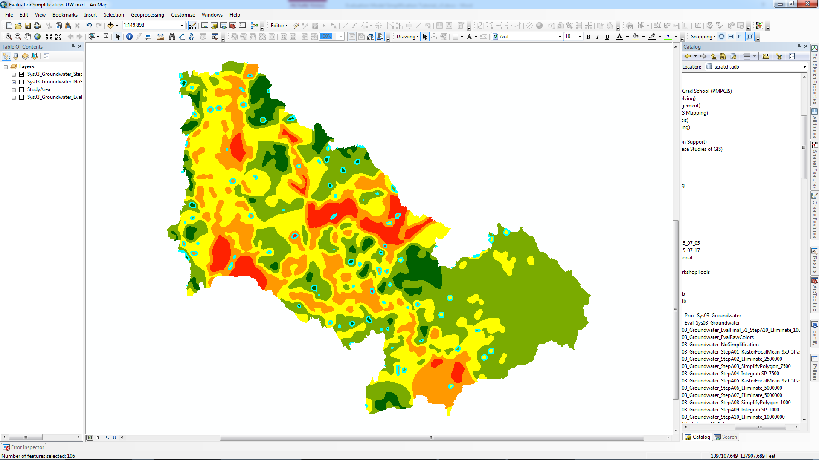

***Data provided by permission of King County***

1. When you are satisfied with your selected features that will be removed, in the GeodesignWorkshop toolbox, open **3. Eliminate Assist**.
2. Input Evaluation Layer is the layer you would like to simplify. Note that this *must* be a layer, not just the file path of a feature class on disk. As such, this tool is much easier to run in ArcMap. In addition, the layer must have a selection on it or the tool will not run.
3. Output Simplified Evaluation Feature Class you should put in your project geodatabase or feature dataset.
4. **Tutorial values:**
   1. On the layer ***Sys03_Groundwater_StepA01_RasterFocalMean_9x9_5Pass***, perform a Select By Attributes:

Shape_Area < 2500000

(This should select 106 features.)

* 1. Input Evaluation Layer:

***Sys03_Groundwater_StepA01_RasterFocalMean_9x9_5Pass***

* 1. Output Simplified Evaluation Feature Class:

***…Tutorial.gdb\Phase3_Eval_Sys03_Groundwater\Sys03_Groundwater_StepA02_Eliminate2500000***

1. Click OK.

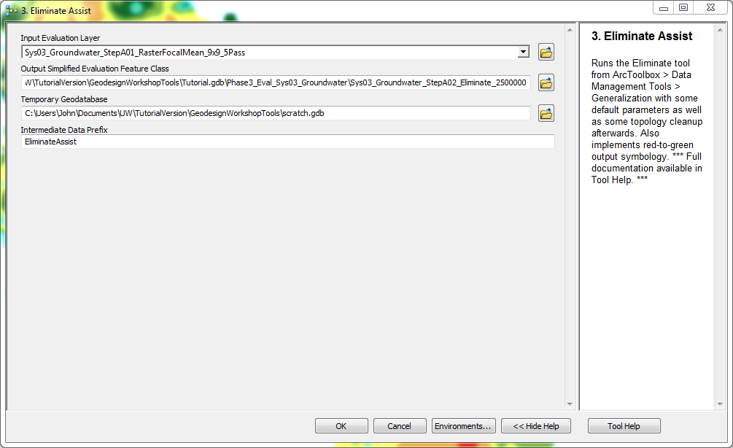

The output should be added to your map. Clear you selection from the previous layer to make it easier to see this new layer.

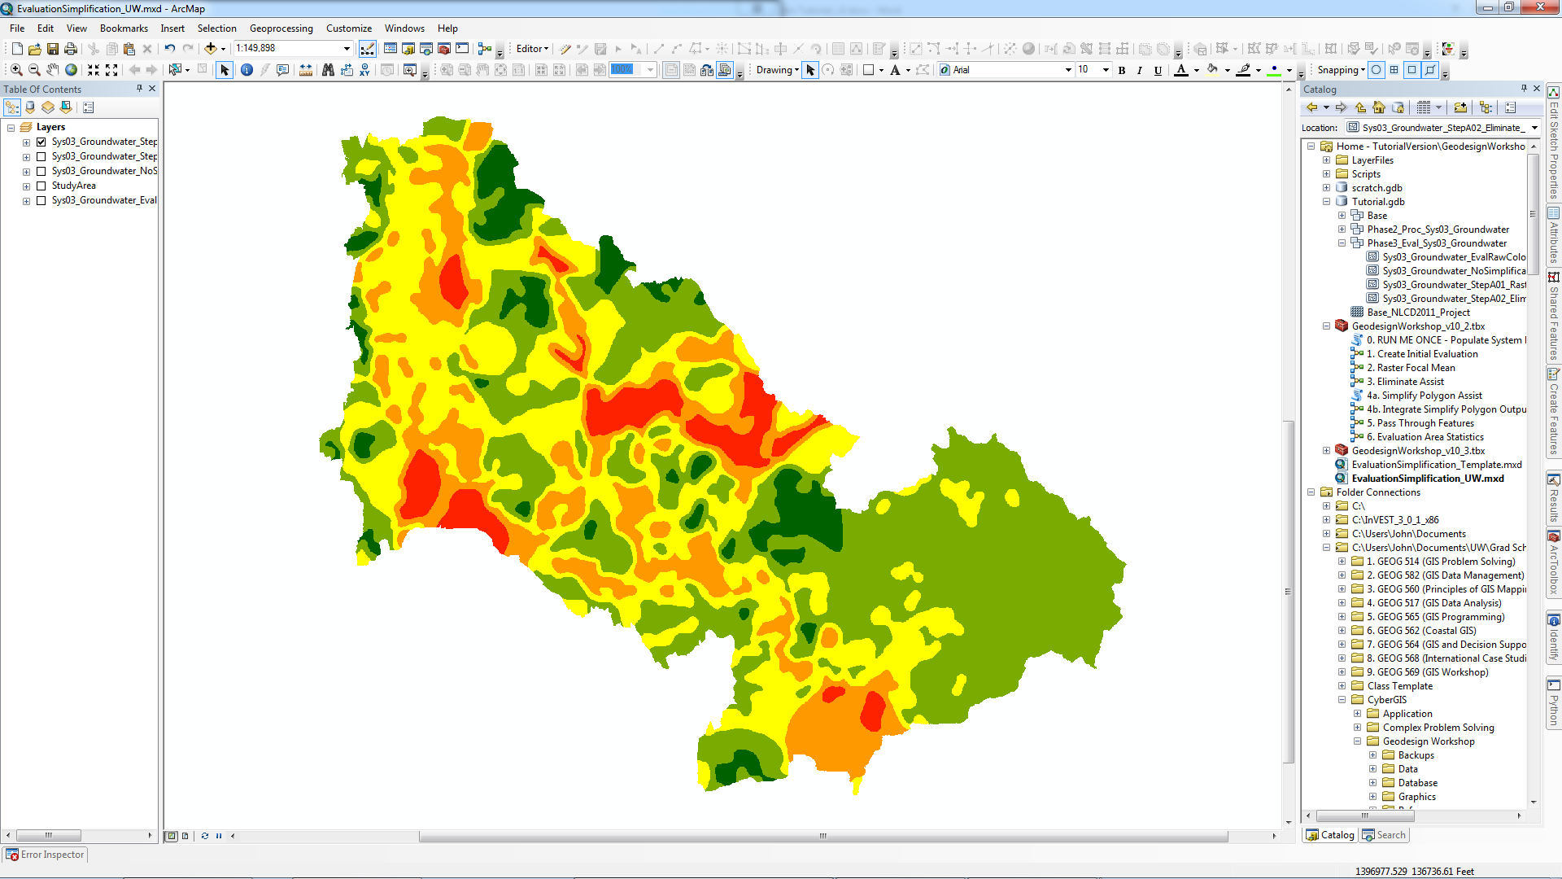

***Data provided by permission of King County***

The tool often needs to be run twice in order to remove any selected features that had been “shielded” from being merged by being completely surrounded by other selected features. To check if this needs to be done, try to run the same selection method that you did on the first layer on this new layer and see if any features are selected. This is much easier to do if you did a Select By Attributes rather than a manual selection. You may go through this section for the tutorial for practice, but no features will be selected, so you may also skip if you wish.

1. Clear the selection from your previous layer.
2. Open Select By Attributes again (if that is what you did before).
3. Copy or remember your selection query.
4. ***Change the target Layer to the newly created layer.*** This is important because Select By Attributes will default to the last layer you selected from (i.e. the previous dataset). (see next page)
5. Paste or retype the selection query and click OK.
6. If any features that you intended to remove remain in the new layer, they should be selected and you can run the tool again with the new layer as the Input Evaluation Layer and a different name for the Output Simplified Evaluation Feature Class. Otherwise, if no features are selected, you can continue to the next step of the workflow.
7. If you had to run the tool a second time, it may also be possible that you need to run it a third time, so check it the same way you did just before this.

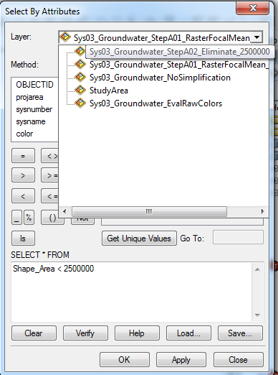

**Advantages:** Speed, clarity, and flexibility. The Eliminate tool allows you to immediately see which features you will remove and it removes them in the most straightforward way possible. It also gives you the ability to select which features those are with a variety of methods (Select By Attributes, manual, etc.). The tool is also very “safe” to use, meaning that it does not introduce oddities that need to be corrected by later tools like **2. Raster Focal Mean** does with blocky polygon boundaries. As such, you can run the Eliminate tool at any point in your workflow, including at the end. Finally, the tool serves as a nice “last resort” if you find that other tools you are using are not removing certain features you would like to see removed.

**Disadvantages:** Repeatability, clunkiness, and imbalance. While some of the methods of selecting features for removal are repeatable, such as with Select By Attributes, this is not actually part of the tool itself, so it can be hard looking back to see exactly what you did with this tool. As such, it is important to document in the output file name or in another workflow document the selections you used. The tool can also be clunky for the same reason (running selections before the tool) and because it can sometimes need to be run twice or three times if any selected features “shield” each other. Finally, unlike the **2. Raster Focal Mean** tool, this tool does not produce a “balanced” simplification across the study area. Instead, individual features are selected for removal, which can lead to certain colors’ being removed more than others. For example, if all the G2 features are below the area threshold of your Select By Attributes, that color will simply be removed without a trace from your evaluation.

**4. Simplify Polygon Tools**

Both the **2. Raster Focal Mean** and **3. Eliminate Assist** tools focus primarily on reducing feature count. The two **4. Simplify Polygon** tools take a different and attempt to similar the feature geometry (polygon boundaries) while keeping the number of features intact. This is useful in two main situations, which are handled by changing the Simplification Tolerance parameter. First, it can be useful in your workflow to do a high tolerance run of these tools (e.g. 7500 ft or 2500m). This will straighten/smooth out complex boundaries of your features (e.g. peninsulas and inlets with other features) to create more general “regions” where each color dominates. Secondly, at or near the end of your workflow, it is advised that you run a low tolerance (1000 ft or 300m) pass of these tools just to clean up feature edges on a fine scale without changing the larger geometry. This is important if you have chosen not to run a high tolerance pass of these tools or if you have not run the **Simplify Polygon** tools after running **2. Raster Focal Mean**, as polygon boundaries will otherwise resemble grid cells. In your workflow, you should at least run a low tolerance pass of these tools at some point in your workflow to simplify geometry at a fine scale, usually near the end, and should not run **2. Raster Focal Mean** after this point.

The **4. Simplify Polygon** tool was split in two because the ArcToolbox [Simplify Polygon](http://resources.arcgis.com/en/help/main/10.2/0070/007000000011000000.htm) tool dialog box can be very buggy, so it was moved from the main ModelBuilder tool into a Python script tool in order to bypass the tool dialog box. The second tool contains all of the topology cleanup functions associated with this tool, so should be run immediately after the first one. ***These two tools should be treated as a single tool and run immediately after one another in order to maintain the topology of your evaluation.***

1. In the GeodesignWorkshop toolbox, open **4a. Simplify Polygon Assist**.
2. Input Evaluation Features is the feature class you would like to simplify. ***However, this tool has a bug. In testing, this tool did not like a layer as input. Instead, you should use the full reference (path) to your feature class on disk.***
   1. Make sure that the input looks like a full file path before running.
   2. The output from [Simplify Polygon](http://resources.arcgis.com/en/help/main/10.2/0070/007000000011000000.htm), even run directly from ArcToolbox, was always empty if just an ArcMap layer was used as input. If you are getting empty output, make sure you are using a full file path for input.
3. Output Simplified Evaluation Feature Class you should put in your project geodatabase or feature dataset.
4. Simplification Tolerance is the length of the reference baseline for simplifying bends in polygon boundaries. The larger you set this value, the greater the effect of the simplification will be. (see next page)
   1. The value you enter here will be dependent on the situation you are using it in (see tool introduction on the previous page for more information).
   2. A 7500 feet tolerance was found to be a good value to smooth large sections of polygon boundary. This is useful earlier in the workflow, such as the first time you use this tool.
   3. 1000 feet was found to be a good value to just clean up edges on a fine scale. This is useful late in a workflow or if you are not doing a high tolerance run at all.
5. **Tutorial values:**
   1. Input Evaluation Features:

***…Tutorial.gdb\Phase3_Eval_Sys03_Groundwater\Sys03_Groundwater_StepA02_Eliminate2500000***

(Remember to use the full file path to your feature class this time, not just the ArcMap layer, or the output may be empty!)

* 1. Output Simplified Evaluation Feature Class:

***…Tutorial.gdb\Phase3_Eval_Sys03_Groundwater\Sys03_Groundwater_StepA03_SimplifyPolygon_7500***

* 1. Simplification Tolerance:

7500 Feet

1. Click OK.

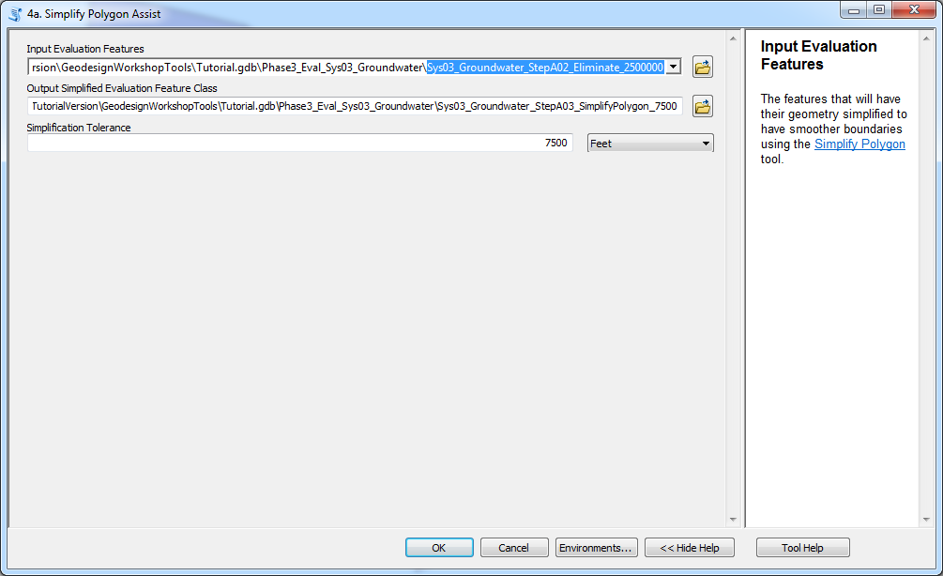

The output will be (hopefully) added to you map. If output is empty, check if you used a full file path for input and try again if need be. You will notice that the output layer looks less “cleaned” than outputs of other tools (e.g. it is unclipped to the study area); this is because this first tool was split off from the geometry cleaning portion, which is in the second tool. We will run this second tool now. You should use this intermediate output as input for anything but **4b. Integrate Simplify Polygon Output**.

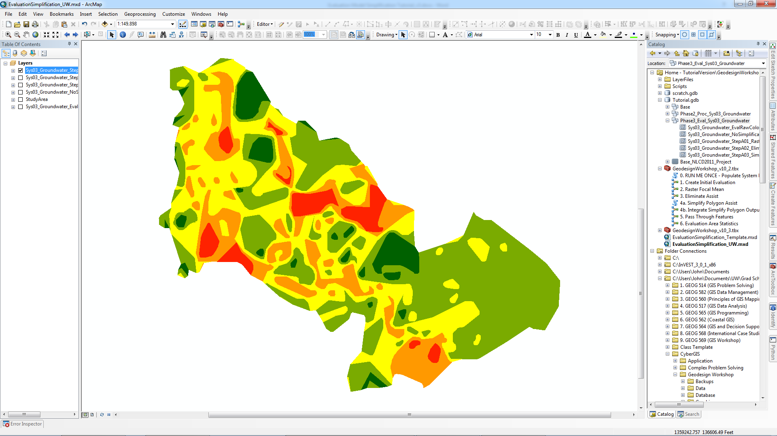

***Data provided by permission of King County***

To clean this intermediate output dataset, we will use the second (companion) tool. Be sure to run this part before running any other simplification tools.

1. In the GeodesignWorkshop toolbox, open **4b. Integrate Simplify Polygon Output**.
2. Simplify Polygon Output Features is the intermediate feature class you just created.
   1. ***You may now use ArcMap layers here again.***
3. Simplify Polygon Input Features is the feature class you used *as input* for the previous tool, **4a. Simplify Polygon Assist**.
   1. ***However, this one suffers from the same bug as the last tool, and must be the full file path of the feature class.***
   2. Leaving this parameter as an ArcMap layer will cause it not to load correctly and will leave gaps around the edges of your output layer.
4. Output Reconciled Evaluation Feature Class you should put in your project geodatabase or feature dataset.
5. Color Priority makes its return here. This parameter is actually not really important if you used the **4a. Simplify Polygon** tool as it will prevent overlaps on its own. However, if you ran [Simplify Polygon](http://resources.arcgis.com/en/help/main/10.2/0070/007000000011000000.htm) directly from ArcToolbox in order to make use out of all the parameters, you should define this parameter if did not have Handling Topology Errors set to “RESOLVE_ERRORS”, as other options can lead to overlap of features.
   1. If you need to define this parameter, you should do so in the same way as during the **1. Create Initial Evaluation** tool for consistency.
   2. It is also good practice just to treat this parameter as if it were necessary and define it as stated above, just in case something odd happens.
6. Manual Color Priority is also back in case you need to use a color priority not in the Color Priority list. Any priority order defined here will override the one in Color Priority.
7. **Tutorial values:**
   1. Simplify Polygon Output Features:

***Sys03_Groundwater_StepA03_SimplifyPolygon_7500***

* 1. Simplify Polygon Input Features:

***…Tutorial.gdb\Phase3_Eval_Sys03_Groundwater\Sys03_Groundwater_StepA02_Eliminate2500000***

(Remember to use the full file path to your feature class this time, not just the ArcMap layer, or the output may have gaps around the edges!)

* 1. Output Reconciled Evaluation Feature Class:

***…Tutorial.gdb\Phase3_Eval_Sys03_Groundwater\Sys03_Groundwater_StepA04_IntegrateSP_7500***

* 1. Color Priority:

“R2>R1>Y>G1>G2” (same as in 1. Create Initial Evaluation)

1. Click OK.

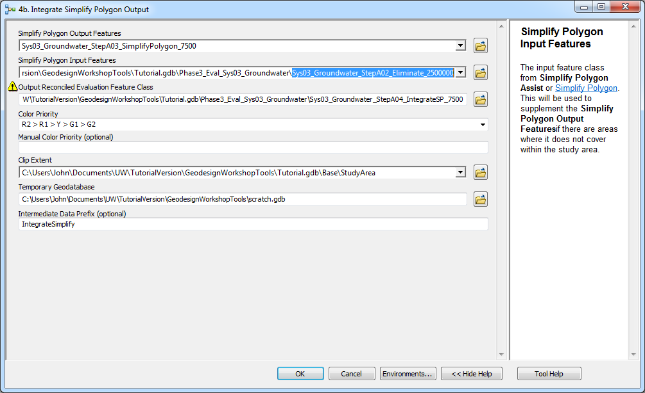

The output dataset should be added to your map. ***It is important here to check that the outer boundary of your evaluation matches with previous datasets (except the last, intermediate one).*** If you used an ArcMap layer as the Simplify Polygon Input Features, this can cause the outer boundary to be left empty. This is because, since the [Simplify Polygon](http://resources.arcgis.com/en/help/main/10.2/0070/007000000011000000.htm) tool changes the boundary of features, it leaves gaps and overruns across the study area boundary. Overruns are easy to handle with a clip, but gaps need a value to fill them in. This is why Simplify Polygon Input Features is a parameter; it uses the previous dataset as the “best guess” for what color these gaps should be. If an ArcMap layer is used for this parameter, it will not load correctly for some reason, and thus the output dataset from **4b. Integrate Simplify Polygon Output** will only be clipped, but not gap-filled, causing mismatch with the study area along the outer boundary. This is more damaging than it might seem, because only this tool and **1. Create Initial Evaluation** are designed to fill gaps. All other tools just clip as part of their geometry cleanup, meaning these outer gaps will not be quickly fixed by the next tool. So, be sure to compare the outer boundary of your output from **4b. Integrate Simplify Polygon Output** with the outer boundary of previous datasets, such as the one you used for Simplify Polygon Input Features. If you have verified that the boundaries match, this dataset is now ready to be used as the input for other tools.

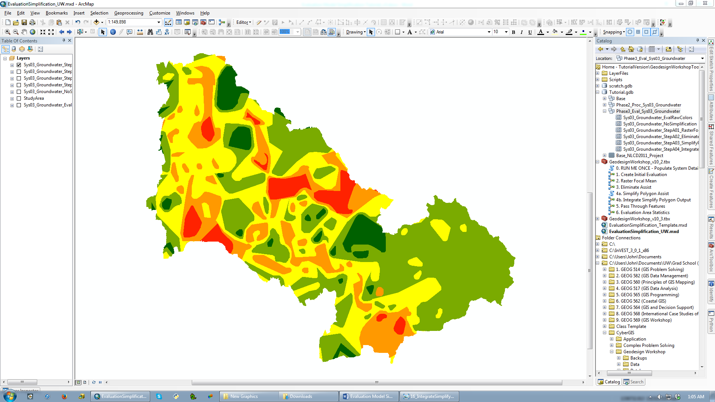

***Data provided by permission of King County***

**Advantages:** The Simplify Polygon tools are the only ones that directly address feature geometry (vertex count) as a way to reduce file size as well – this was discovered late in the process. It gives you a way to simplify if you are not sure you need to remove more features, but still need simplification. This tool is also the only one that clean the grid cell-like polygon boundaries left by **2. Raster Focal Mean** (zoom close to the before and after maps to see this). The tool can also be run at different tolerance levels (e.g. 7500 ft vs. 1000 ft.) to determine if you want to really simplify

**Disadvantages:** Quite a few actually. The split two-tool structure of Simplify Polygon leads to greater chance of error and the bug with two of the parameters can cause frustration or lead to gaps in output data. So, be sure that you use the file path of the feature class (not the ArcMap layer) for both the Input Evaluation Features in **4a. Simplify Polygon Assist** and the Simplify Polygon Input Features in **4b. Integrate Simplify Polygon Output**. Another issue with this tool is that it *straightens* edges more than *smooths edges* (which would entail adding more vertices, which is not desired). This can leave features looking very stark and angular when run with a high (e.g. 7500 ft) tolerance and not the best for a final evaluation (see above). It is recommended actually that you do another run of **2. Raster Focal Mean** after a high tolerance run of these tools in order to round out these corners and produce a more appealing map. A low tolerance run (e.g. 1000 ft) generally does not cause these issues and can be used as a final map. Finally, this tool, more than any other, has a high potential to distort significant features such as lakes and rivers beyond recognition. This is the reason the **5. Pass Through Features** tool was created, to bring these features from an earlier step to the current one.

**Summary**

This completes the description of the 3 main simplification tools available in the GeodesignWorkshop toolbox. Additional information about these tools can be found in their Item Description metadata, including more detailed considerations for parameters. As you use these tools, you will also get a hang for what tool would probably be best next for your evaluation – e.g. Does your evaluation need more *smoothing* (**Raster Focal Mean**), need *small or particular features removed* (**Eliminate Assist**), or need the *geometry of features simplified and straightened* (**Simplify Polygon** tools). You are also free to examine or edit the tools directly in ModelBuilder or Python if you feel comfortable doing so. There is no source code besides the models in the toolbox and the two scripts in the Scripts subfolder affecting how the tools run. If you have any questions or comments about any of the tools, please feel free to email John Ritzman at [jar29@uw.edu](mailto:jar29@uw.edu).

While this completes the description of the tools, this does not comprise a complete description of the general simplification workflow. The workflow is often very iterative and trial-and-error and can pass through all these tools multiple times. Often, the reason to do this is because the output of Simplify Polygon with a high tolerance has very angular, unappealing features, necessitating a run of Raster Focal Mean to smooth them out, necessitating another run through Simplify Polygon with a low tolerance. Additional Eliminate Assists can be mixed in wherever if the feature count still seems too high. ***We found a good goal to be 50-75 features for the final evaluation.*** As an example, here is the workflow used to create the final ***Sys03_Groundwater*** evaluation.

1. **Create Initial Evaluation**
2. **Raster Focal Mean**
   1. 30m cellsize, Rectangle 9x9 cells, 5 pass
3. **Eliminate Assist**
   1. Shape_Area < 2500000 (sqft)
4. **Simplify Polygon/Integrate Simplify Polygon Output**
   1. 7500 Feet tolerance *(left features looking very angular, see prev. page)*
5. **Raster Focal Mean**
   1. 30m cellsize, Rectangle 9x9 cells, 5 pass *(to round feature boundaries)*
6. **Eliminate Assist**
   1. Shape_Area < 5000000 (sqft) *(higher threshold to remove more features)*
7. **Simplify Polygon/Integrate Simplify Polygon Output**
   1. 1000 Feet tolerance *(just to straighten grid cell-like boundaries)*
8. **Eliminate Assist**
   1. Shape_Area < 10000000 (sqft) *(even higher threshold)*

In order to keep track of the steps that you do, we found it easiest to use suffixes for you file names like “***_StepA03_SimplifyPolygon_7500***”, similar to those used in the tutorial, that include information about what tool and parameters you used to create that dataset. For each successive step you do, you can advance the number (e.g. ***_StepA04_IntegrateSP_7500***), or if you decide to take your workflow in a different direction instead, you can change the letter after the step (e.g. ***StepB03_RasterFocalMean_9x9_5Pass***) and then keep that letter for successive tools after that. This will help ArcCatalog automatically sort your data for you into “runs”, which will become important as you will quickly find yourself with many datasets and it will be become hard to keep track of them, especially since you might try several different tools or parameter combinations at each step.

There is also a support tool called **5. Pass Through Features**, which allows you to transfer features from one step to another, so you might do two runs of several tools with different types of simplification and then transfer some of the features from one line into the other. This is described in the section after next.

**Finishing the tutorial**

If you have been following the tutorial so far, this section will lead you through the second pass of the simplification workflow so that you can have an example final evaluation. If you are not following the tutorial, you can skip to the next section.

First, we will run **Raster Focal Mean** again to round the angular features (144 left).

1. Input Evaluation Features:

***StepA04_IntegrateSP_7500***

1. Output Simplified Evaluation Feature Class:

***…Tutorial.gdb\Phase3_Eval_Sys03_Groundwater\Sys03_Groundwater_StepA05_RasterFocalMean_9x9_5Pass***

1. Simplification Neighborhood:

Rectangle: 9 x 9 cells

1. Passes:

5

1. Import Cellsize:
   1. (this is 30m in feet, the resolution of the raster below)
2. Snap Raster:

***…Tutorial.gdb\Base_NLCD2011_Project***

118 features left. Next, we will run **Eliminate Assist** again to remove small features.

1. Run a Select By Attributes on ***Sys03_Groundwater_StepA05_RasterFocalMean_9x9_5Pass***:

Shape_Area < 5000000

*(This is a higher threshold than before, to remove more features; 59 features should be selected.)*

1. Input Evaluation Features:

***Sys03_Groundwater_StepA05_RasterFocalMean_9x9_5Pass***

1. Output Simplified Evaluation Feature Class:

***…Tutorial.gdb\Phase3_Eval_Sys03_Groundwater\Sys03_Groundwater_StepA06_Eliminate_5000000***

59 features left. We will run a low tolerance **Simplify Polygon Assist** to clean edges.

1. Input Evaluation Features:

***…Tutorial.gdb\Phase3_Eval_Sys03_Groundwater\Sys03_Groundwater_StepA06_Eliminate_5000000***

(Remember to use the full file path to your feature class this time, not just the ArcMap layer, or the output may be empty!)

1. Output Simplified Evaluation Feature Class:

***…Tutorial.gdb\Phase3_Eval_Sys03_Groundwater\Sys03_Groundwater_StepA07_SimplifyPolygon_1000***

1. Simplification Tolerance:

1000 Feet

Next, we will run its companion **Integrate Simplify Polygon Output**.

1. Simplify Polygon Output Features:

***Sys03_Groundwater_StepA07_SimplifyPolygon_1000***

(Can use the ArcMap layer for this parameter.)

1. Simplify Polygon Input Features:

***…Tutorial.gdb\Phase3_Eval_Sys03_Groundwater\Sys03_Groundwater_StepA06_Eliminate_5000000***

(Remember to use the full file path to your feature class this time, not just the ArcMap layer, or the output may have gaps around the edges!)

1. Output Reconciled Evaluation Feature Class:

***…Tutorial.gdb\Phase3_Eval_Sys03_Groundwater\Sys03_Groundwater_StepA08_IntegrateSP_1000***

1. Color Priority:

“R2>R1>Y>G1>G2” (same as in 1. Create Initial Evaluation)

Finally, we will run one more **Eliminate Assist** to remove even more small features.

1. Run a Select By Attributes on ***Sys03_Groundwater_StepA08_IntegrateSP_1000***:

Shape_Area < 10000000

*(This is an even higher threshold than before, to remove more features; 14 features should be selected.)*

1. Input Evaluation Features:

***Sys03_Groundwater_StepA08_IntegrateSP_1000***

1. Output Simplified Evaluation Feature Class:

***…Tutorial.gdb\Phase3_Eval_Sys03_Groundwater\Sys03_Groundwater_StepA09_Eliminate_10000000***

This completes the tutorial simplification workflow. You reduced an evaluation feature class from 1256 features to 45 while maintaining the major patterns across the study area as much as possible. Compare this layer to your one from Create Initial Evaluation (***_NoSimplification***). One final step that may be useful is, when you feel you have simplified your evaluation as much as you want, use [Copy Features](http://resources.arcgis.com/en/help/main/10.2/0017/001700000035000000.htm) from ArcToolbox to save this step more obviously as a “completed” evaluation. For example, use this to copy this last layer to a new feature class that will allow you to compare different “final versions” (this is v1) if you need to run another simplification on your system again: ***…Tutorial.gdb\Phase3_Eval_Sys03_Groundwater\Sys03_Groundwater_EvalFinal_v1_StepA09_Eliminate_10000000***

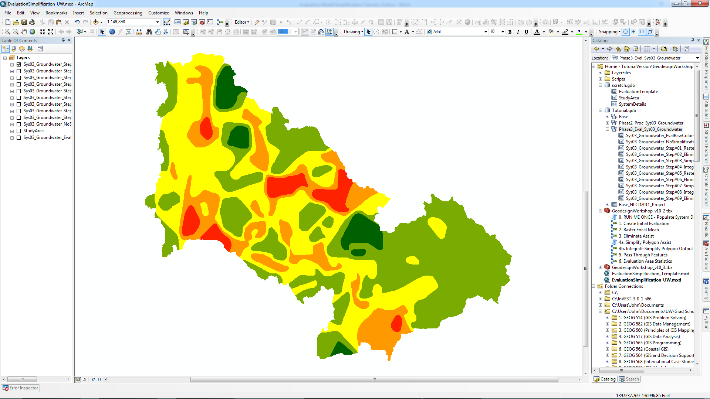

***Data provided by permission of King County***

**6. Support Tools**

This document concludes with a brief description of two final tools in the GeodesignWorkshop toolbox that can help you during and after your workflow.

**5. Pass Through Features**

During your workflow, you may find that certain important features such as lakes or rivers are simplified beyond recognition. This can happen especially with the **Simplify Polygon** tools that straighten edges. To give a way to save these features, this tool was created to transfer features from one evaluation features class to another (“passing them through”). This allows you to bring less simplified features from earlier steps to later steps. To use it, **select the features that you want to transfer from the first layer** (otherwise all features will be transferred) and use that as your Pass-Through Features. Put your destination feature class as the Target Features. This tool creates a new feature class to avoid overwriting the old one, making this a new “step” in your workflow.

The tool will remove any portions of features in the Target Features below where the selected Pass-Through Features are to avoid any overlap when they are added and will perform some geometry cleaning as well. That said, it is important to keep in mind that these “passed through” features may be at a different stage of simplification than the rest now. For example, they may still have the grid cell-like boundaries from Raster Focal Mean, so make sure you pass them through before making any important step in your workflow like a final low-tolerance pass of Simplify Polygon. Finally, it is important that both the Pass-Through Features and Target Features are feature classes that are already in the Evaluation Template schema (i.e. they at some point when through **Create Initial Evaluation**). **Do not attempt to introduce new features from non-evaluation feature classes using this tool, as it will fail on the Append step.**

**6. Evaluation Area Statistics**

This tool is best used at the end of your workflow to get a summary of your simplified evaluation feature class. It will produce a table with the number of features, area (in several units), and percentage area of each color (R2, R1, Y, G1, G2) in your feature class along with the total number of features and area. This can be useful for establishing targets for a geodesign workshop and also just to see the effect of your simplification. Running this on your first evaluation from **Create Initial Evaluation** and comparing can show you if a color “gained” or “lost” ground (percentage area) during the evaluation, showing you how “fair” your simplification was. The area fields in this table are also dependent on the units of your input (this is not automatic), so be sure to select “Feet” or “Meters” as your Original Units. If your coordinate system is not in either feet or meters, use the [Project](http://resources.arcgis.com/en/help/main/10.2/0017/00170000007m000000.htm) tool in ArcToolbox to project your fc to one that is.

**Again, for any questions or comments, please contact John Ritzman at** [**jar29@uw.edu**](mailto:jar29@uw.edu)**.**

**Good luck, and happy geodesign-ing!**